Case 5-Asia-Japan-Haniwa-Bust of Warrior with Helmet-Kofun Period-250 to 538 CE

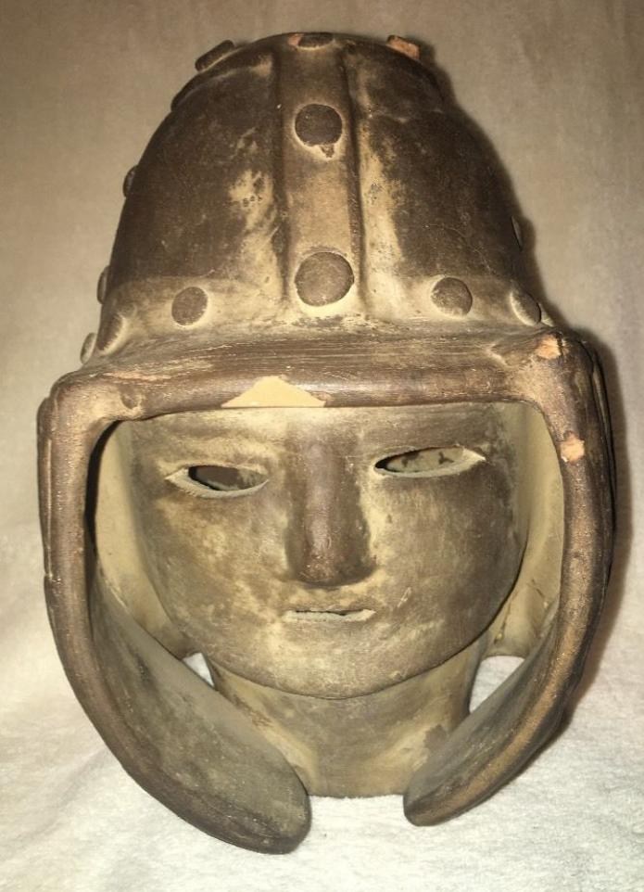 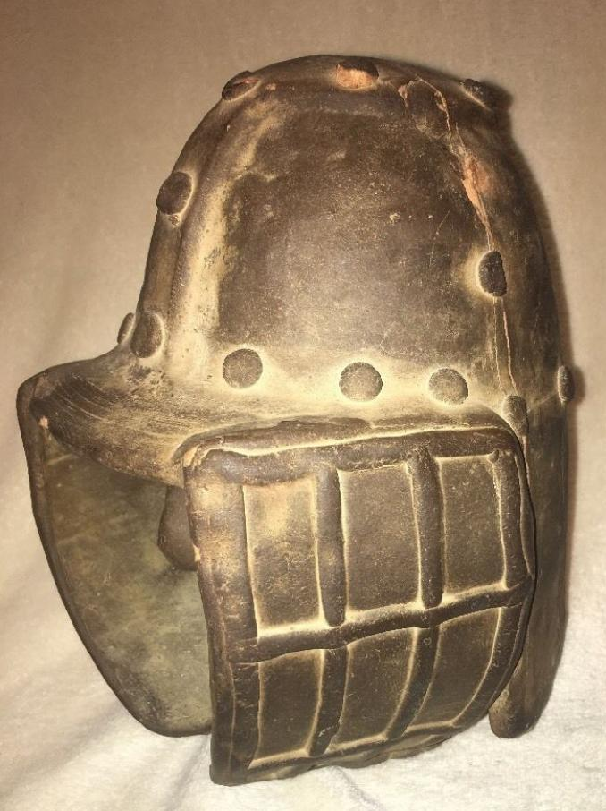 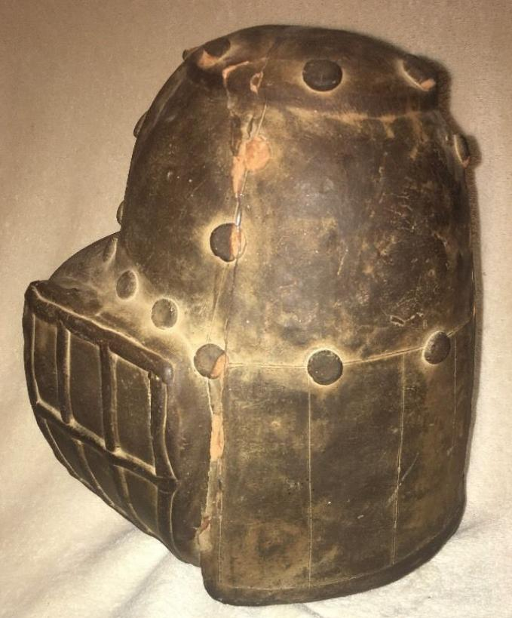 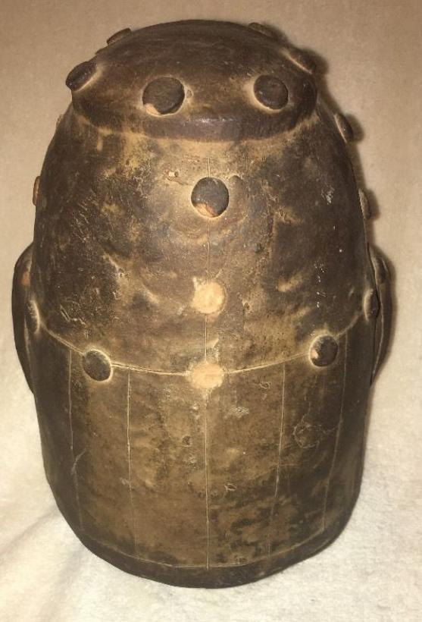 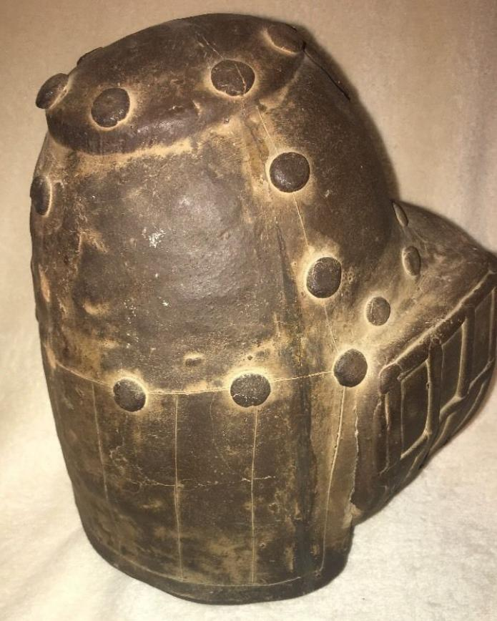 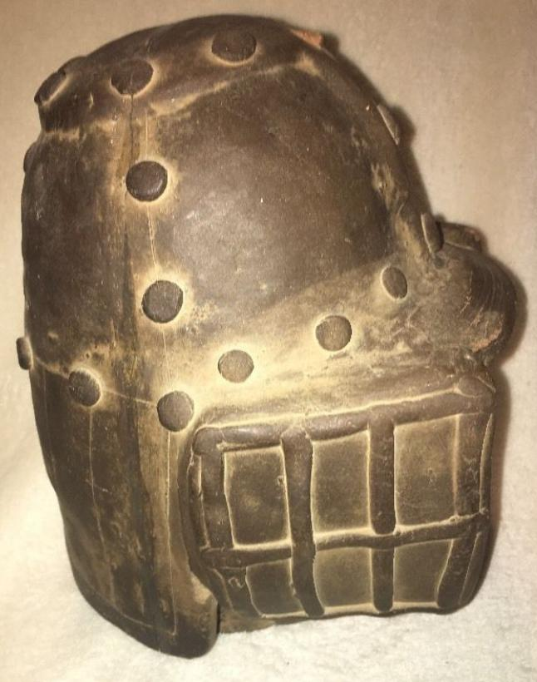 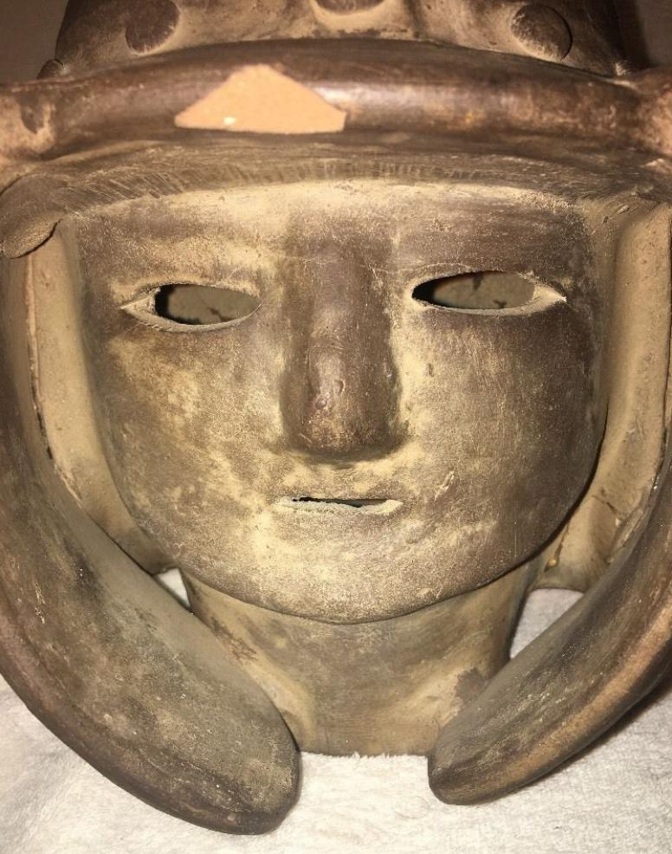 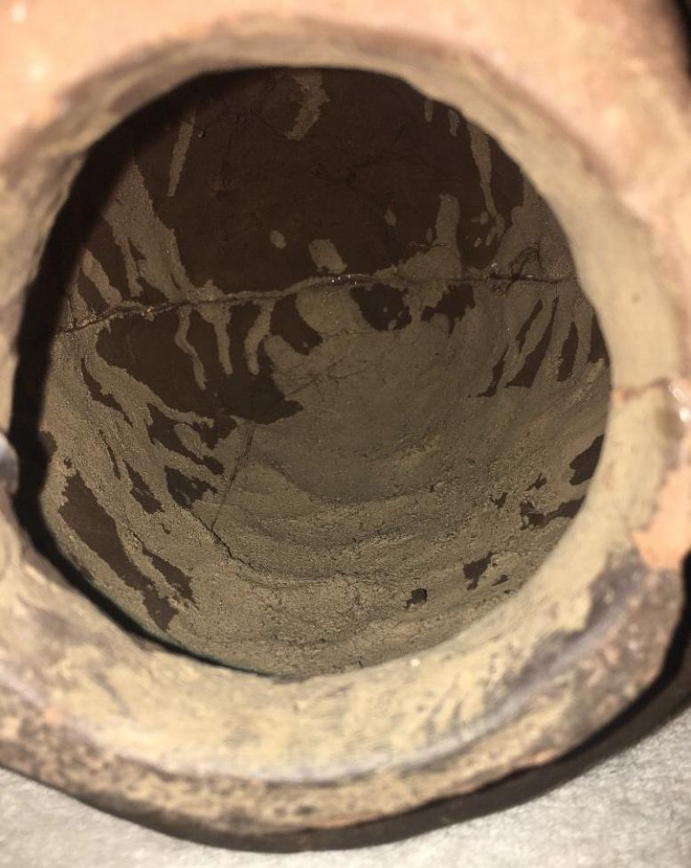

Formal Label: Japanese Haniwa Haniwa-Bust of Warrior with Helmet, Kofun Period, 250-538 AD-CE

Accession Number: NB 1667.A2

Date or Time Horizon: 250 to 538 AD-CE

Geographical Area: Japan

Cultural Affiliation: Kofun Period

Medium: Terracotta

Dimensions: 10 in

Weight:

Provenance: U.S. Naval Captain, Occupied Japan, 1947.

**Condition:** Mended cracks.

**Discussion**: This head of a man with helmet and cheek pieces provides a detailed picture of hos strips of metal were riveted to construct the helmet with the cheek pieces bent around the head and reinforced with a grating that looks welded on.

**References:** Miki, Fumio. 1961. Haniwa : the clay sculpture of protohistoric Japan / English adaptation by Roy Andrew Miller. Rutland, Vt./ Tokyo, Japan: C.E. Tuttle, [1961]